| Task | Specification | Test | Status | Owner |
| --- | --- | --- | --- | --- |
| Mouse Movement | Mouse can be moved to all corners of the screen by the program. | While running the main program use hand movements to reach all corners. | Passed | Zane |
| Mouse Actions | The program must be able to right click, left click, scroll, and double left click. | While running the main program use hand gestures to initiate all configurable mouse actions. | Passed | Zane |
| Mouse Input Error Handling | The program must properly handle all invalid inputs. | Intentionally create errors that are passed to the input mapping subsection. | Passed | Zane |
| Mouse Smoothing Function | Mouse smoothing when turned on generates the frames as specified in the GUI (to the limitations of the hardware) | Using the GUI activates mouse smoothing and checks different amounts of smoothing. | Passed | Zane |
| Mouse Smoothing Error Handling | Mouse smoothing program does not throw an error or leave the terminal running (the process did not end properly). | When initializing the mouse smoothing thread, check for its existence as a zombie process after the main program terminates. | Passed | Zane |
| Gesture positioning | The coordinates of the hand should be calculated when deleting the error points. | Check position calculations in terminal and compare them to actual hand position data | Passed | Daniel |
| Velocity accuracy(redacted) | The output velocity of the moving hand should be close to a multiple of its true velocity. | Using a phone to record hand movements, measure the hands true speed and the velocity calculated by the algorithm | Passed | Daniel |
| Position tracking accuracy | In the position tracking program, the mouse should move to the relative position of the hand according to the scale of the computer screen. | Perform horizontal movement, vertical movement, and circle movement using your hand. Compare the moving path of the mouse with the movement of the hand. | Passed | Daniel |
| Average Velocity accuracy | In the average velocity program, the mouse should move according to the average weight velocity of the user’s hand. | Perform horizontal movement, vertical movement, and circle movement using your hand. Compare the moving path of the mouse with the movement of the hand. | Passed | Daniel |
| Hand Gesture Recognition | ML model can recognize the user's hand gestures. | Ask someone with no prior experience with the program to try to imitate the gestures. The results will be recorded. | Passed | Oscar |
| Gesture Recognition Accuracy | ML model can correctly identify and categorize hand gestures at least 90% of the time. | Using the results from the testing with an outside party, calculate the accuracy of the model. | 92%, Passed | Oscar |
| Functional Radar System | The IWR6843AOPEVM properly communicates with the computer and transmits data. | Check frame data for correct output in the terminal. | Passed | Greyson |
| Data Decoding(redacted) | The python script accurately decodes the TLV data seen from the radar. | Use the parser algorithm to obtain relevant data. | Passed | Greyson |
| Radar Angle and Distance(redacted) | The radars can capture gestures and pointer positions within a 60 degrees from the horizontal, and range up to 2 feet | Test radar tracking and gesture recognition at different angles and distances. | Passed | Greyson |
| Hand Size | Radar will recognize gestures regardless of hand size. | Asked multiple people with varying hand sizes to test the gesture recognition. | Passed | Oscar |
| GUI | Available settings change the relevant functionality of the program. | Changed every setting individually, and in combination with other settings. | Passed | Greyson |
| GUI | If a setting input is invalid the relevant variables will not be changed. | Intentionally input invalid settings into GUI. | Passed | Greyson |

**Mouse Movement - Radar was used to control the cursor position. Passed**

**Mouse Actions - Radar was used to record gestures and turn them into mouse actions like left click and right click. Passed.**

**Mouse Input Error Handling - Imputed an erroneous variable value and checked for correct behavior of the program. Passed**

**Mouse Smoothing Function - When using, check to make sure when it is turned on, more frames are generated (based on the variable in GUI). i.e. creates more than 30 frames per second. Passed**

**Mouse Smoothing Error Handling - Program closes without leaving a zombie process. Passed see image at end of document.**

**Gesture Positioning - Measured the approximate x,y,z coordinates of the hand with respect to the radar, and compared them with the radar output. In close proximity < 5inches, coordinates are not reliable, but they become more reliable further out. The y-axis has an offset of about .1m**

**Position tracking accuracy - The mouse movement has the same direction as the movement of the user’s hand. The relative position movement is modified by the user's setting of mouse sensitivity in the software.**

**Average Velocity accuracy - The mouse movement has the same direction as the movement of the user’s hand. The relative position movement is modified by the user's setting of mouse sensitivity in the software. Average velocity and position tracking use different algorithms but have similar mouse behavior.**

**Hand Gesture Recognition - Asked a person with no prior experience to test it.**

**Gesture Recognition Accuracy - Asked some people to try the mouse without prior experience**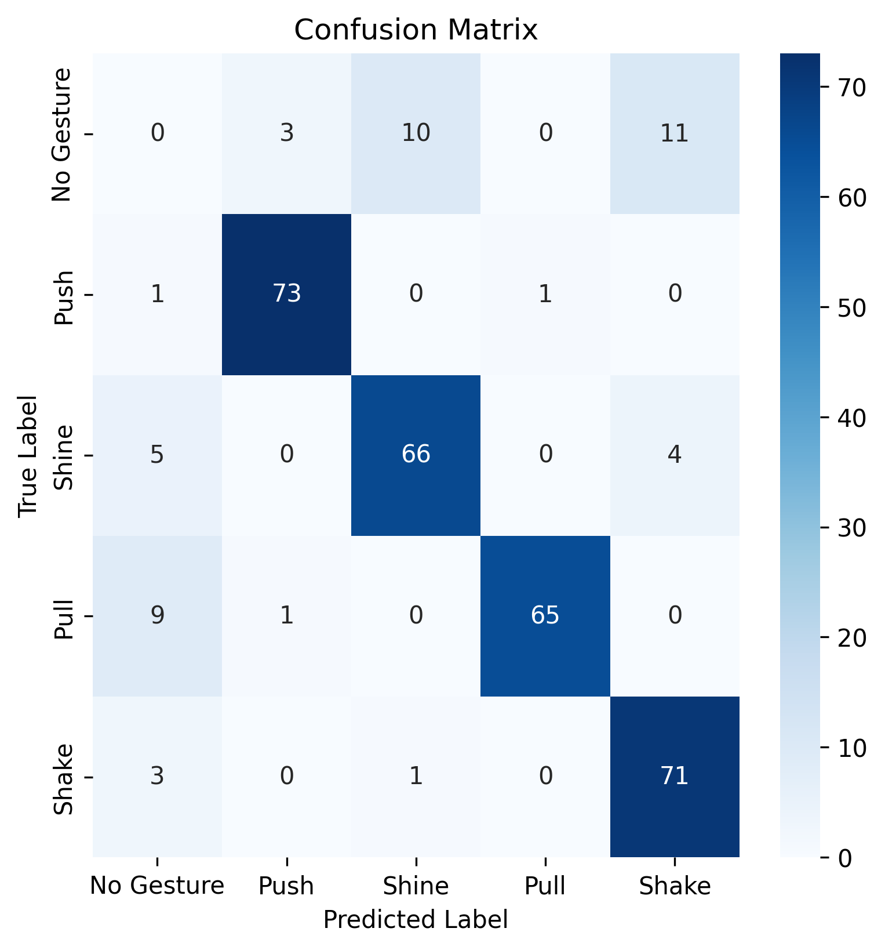

Accuracy = 92%, One false positive every 75 sec.

| Functional Radar System | The IWR6843AOPEVM properly communicates with the computer and transmits data. | Check frame data for correct output in the terminal. | Passed | Greyson |
| --- | --- | --- | --- | --- |

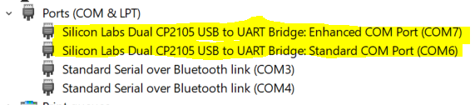



| Data Decoding(redacted) | The python script accurately decodes the TLV data seen from the radar. | Use the parser algorithm to obtain relevant data. | Passed | Greyson |
| --- | --- | --- | --- | --- |

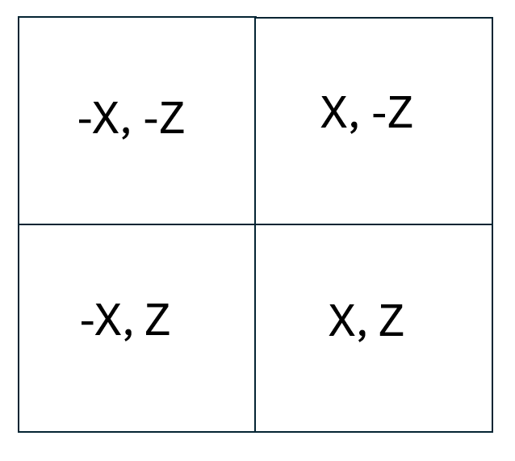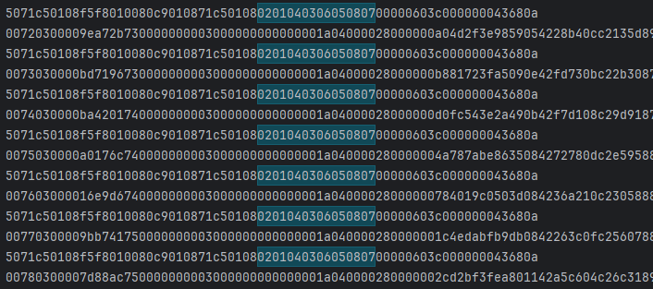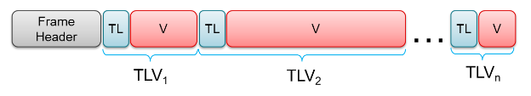

* Define a parser in code
* radarData = my_parser.readAndParseUartDoubleCOMPort()
* Calls gui_parser:
  + def readAndParseUartDoubleCOMPort(self):
  + Searches hex output for TI’s ‘Magic Word’ (0201040306050807)
  + Stores version, frame length and data, **frameData ptr**
  + Calls parseFrame
    - def parseStandardFrame(frameData):
    - Uses frameData ptr to jump to frame Data (TLV’s)
    - Calls tlvHeaderDecode to store tlvType (parsePointCloudTLV) and length
    - Number of TLV’s = number of points detected
    - Calls parseTLV
      * def parsePointCloudTLV(tlvData, tlvLength, outputDict):
      * Extracts X, Y, Z, Doppler from each point
      * Stores data to outputDict

**Radar Angle and Distance(redacted) - The radar was configured to work within 2ft and 90 degrees in elevation and azimuth(horizontal). Within the code we added boundaries that changed the tracking space to about 60 degrees when the hand is about 1.5ft away. Angles were measured to be 55-60 degrees.**

**Different Hand Sizes - Asked multiple people to try to do gestures in front of the radar. Passed**

| GUI | Available settings change the relevant functionality of the program. | Changed every setting individually, and in combination with other settings. | Passed | Greyson |
| --- | --- | --- | --- | --- |

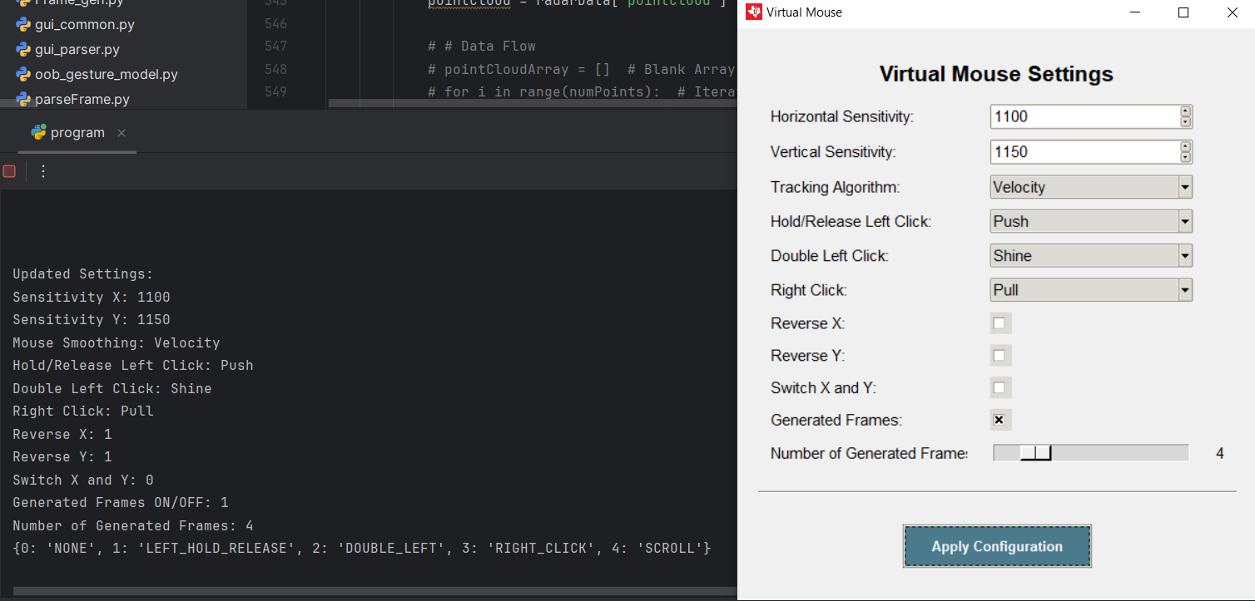

| GUI | If a setting input is invalid the relevant variables will not be changed. | Intentionally input invalid settings into GUI. | Passed | Greyson |
| --- | --- | --- | --- | --- |

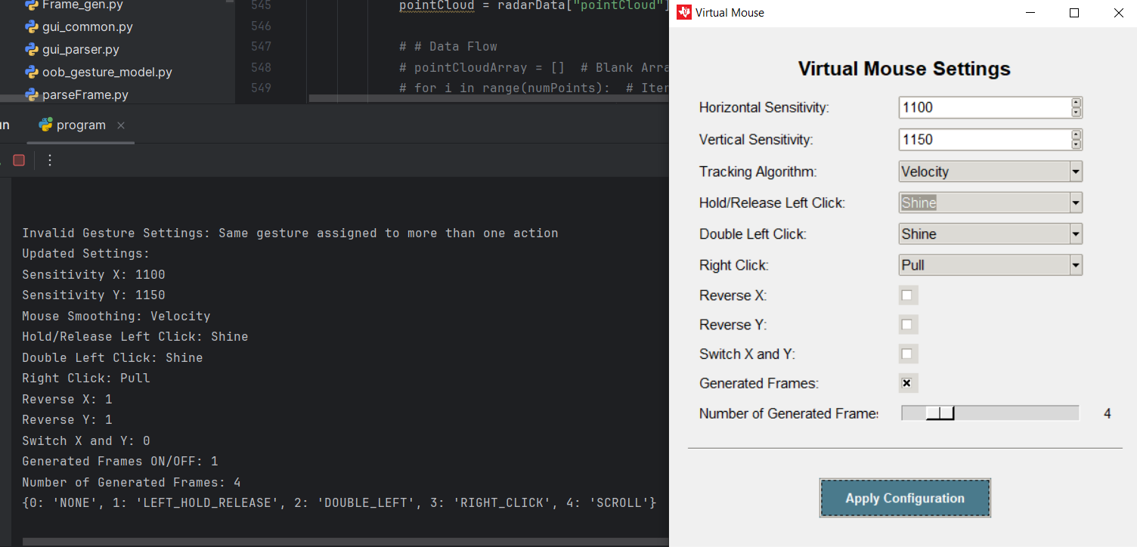

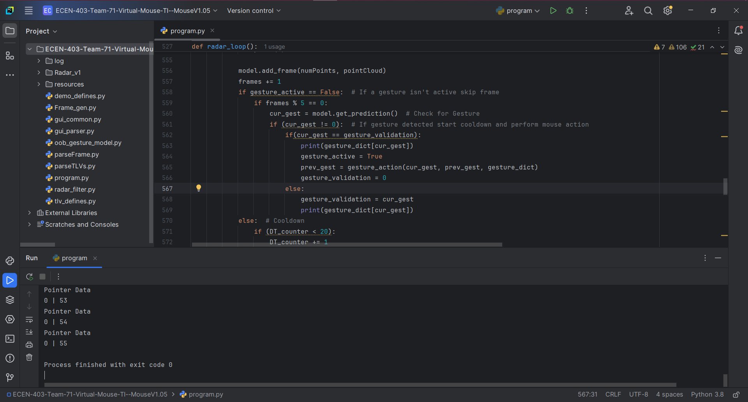

Shows program closes properly without zombie threads.